Lesson Plan Template
Required fields
Title | 3Discover your world!
Author | Éva Tóth, Nagykátai Ipari Technical School
Type of schol | Technical and vocational secondary
Suitable for Age groups  Web page of the project | 15-17  https://www.pinterest.ru/evatoth547727/3discover-your-world/
School Subject | English as a Second Language, Geography, ICT, Social Studies
Description of the project | In the project, students discovered their home town and Brno, then compared the results. They had to use skills for real-life situations as they had never done it before: checking different means of transport between their hometown and Brno, calculating the cost of travel, changing the currency, exploring local food.
Timing | The duration of the project was 2,5 months, incorporating English lessons and some ICT lessons too. Approx 2 lessons per week,
Outline
What library / CC app have you used? | Corinth, Culture
Resources needed  Assessment criteria | *Presentation,* Video, *Gallery of images
Optional fields
Audiovisual outcome | *photos
What CC objects have you used | Cultural objects found in Brno.
What 21 century skills | The main strength of the project lied in not only just connetcing several subjects such as English as a Second Language (but project relating to History, Geography, IT, Social Studies) but also contributing to the development of 21st century and real-life skills (like using Google Maps, changing currency, calculating travel costs). Within the project, primary and secondary school students worked together.
What type of technology/apps | 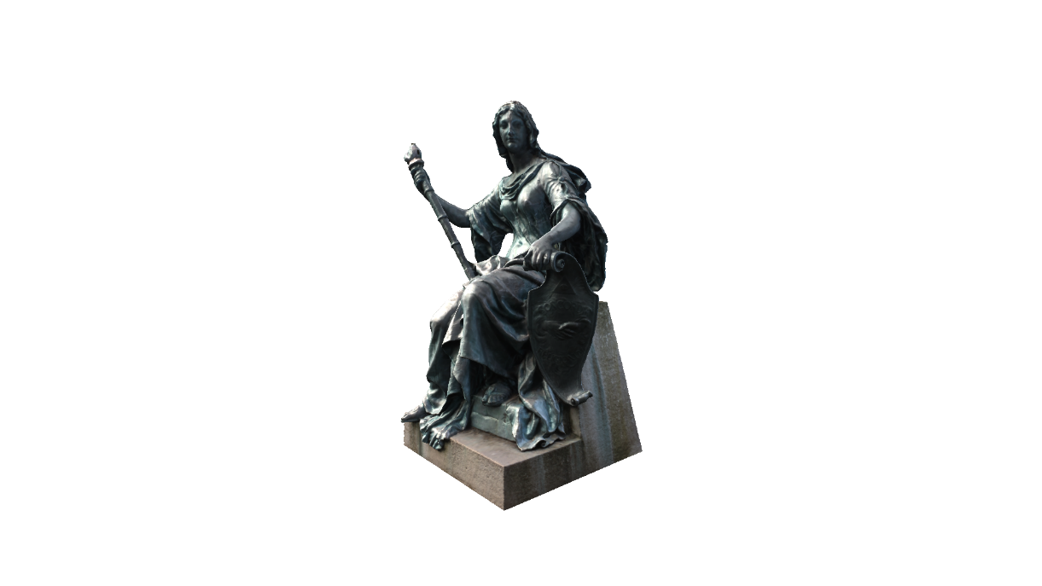  Being part of the itec radical pilot, our project was radical technology speaking for many reasons: the use of Windows 8- it was a new experience both for us and my students; they were eager to see the working of Corinth and Powerpoint on Windows 8; they have never seen any device with it before. Technologically, for me what seemed radical was the incorporation of a rather science-related software into a language project. We also added many other smaller softwares and applications that they had never used before even at IT lessons e.g. mindmaps, working together in Google documents. We used several platforms for online communication and collaboration such as Google docs, Twinspace, Pinterest, linoit. We were in constant online connection during the project. Students could reflect on each other’s work.

