student

What is SARS-CoV-2
Life Science, Biology

In this lesson, we will explain what a virus is, what it consists of, and how the new coronavirus SARS-CoV-2 looks like. We will compare viruses with bacteria in terms of treatment of infections they cause and finally, we will try to think of a way a completely new virus could look like.

- Introduction: What is a virus
- The origin and structure of the new coronavirus
- The difference between a virus and a bacterium and why antibiotics do not work on COVID-19

virus, coronavirus, reproduction, infection, bacteria, antibiotics

Introduction: What is a virus

First of all, let’s remind ourselves about what a virus is:

Viruses are parasitic particles that replicate only in cells of other organisms. They attack all types of organisms – not only plants, fungi, and animals, but also bacteria. Viruses form a special category on the border of living and inanimate nature.

What have they got in common with living organisms:

- they are made up of organic substances (proteins, nucleic acids, ...)
- they have the ability to reproduce

Properties different from living organisms:

- they are not made up of cells
- they are not capable of independent living or independent reproduction
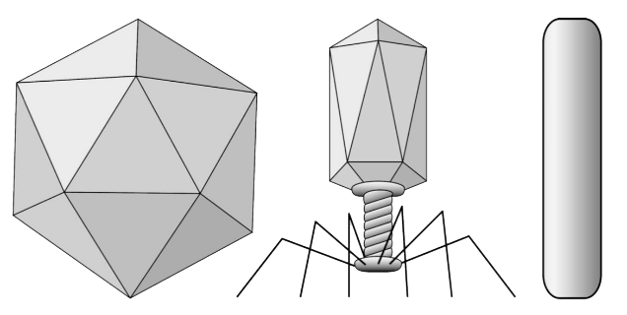

- What are viruses?
- Are they alive?
- What body parts do you think they need for their survival?
A virion is a specific particle by which a virus spreads from one cell to another:

Size of virions: tens of nm on average (not visible by optical microscopes)
Shape: simple (rod-shaped, spherical), often regular (due to the crystalline structure of the proteins that make up the virion envelope)

Let’s have a look at what parts a virion contains – the structure of a virion looks something like this:
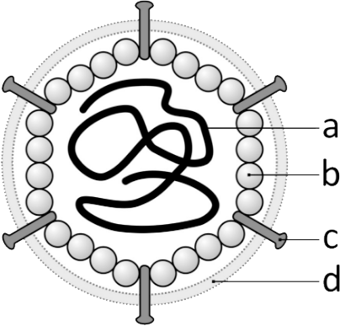

- nucleic acid core (DNA or RNA) – carries information about the construction of future new virions and "instructions" for the cell on how to create them
- capsid – protects nucleic acid, molecules are often arranged in regular crystals
- spikes (complexes of proteins and carbohydrates) - used to recognize the correct host cell and attach to its surface
- membrane envelope (only some viruses have it) - auxiliary protection, the virion obtains it from the cytoplasmic membrane of the host cell

Resource: https://www.livescience.com/53272-what-is-a-virus.html
https://www.livescience.com/53272-what-is-a-virus.html

The origin and structure
of the new coronavirus
Open the coronavirus 3D model and read the model introduction by clicking the Introduction button in the bottom panel.
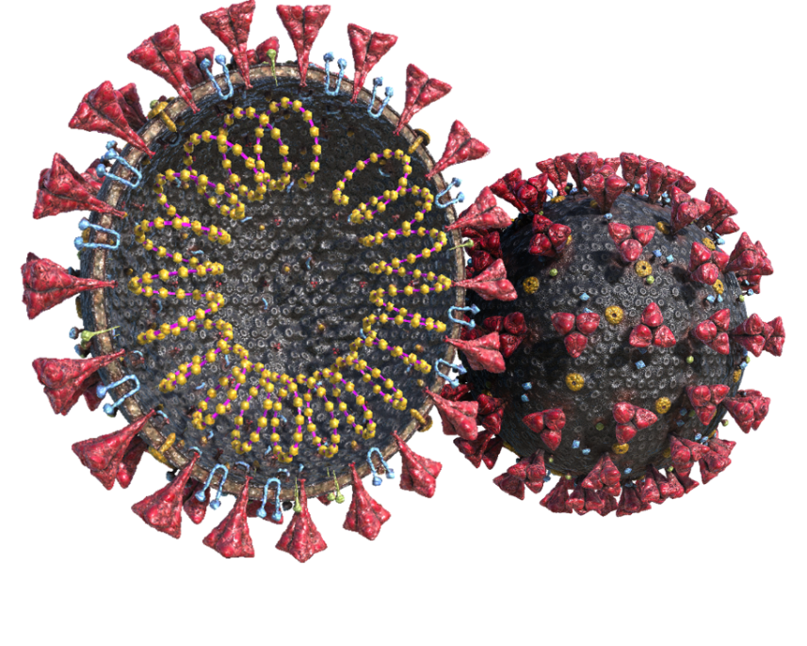
Otevřete 3D model

For the time being, we can say with certainty that coronaviruses belong to the enveloped single-stranded RNA viruses with positive polarity. Their name is derived from the characteristic arrangement of the surface structures of the lipid envelope in the shape of a solar corona. They reach the size of about 120 nanometers. Their genome contains 30,000 bases, which is the most among well-known RNA viruses with non-segmented genomes (by comparison, the human genome contains 3.1 billion bases).

Resource: https://en.wikipedia.org/wiki/Coronavirus

Click through the different parts of the model and focus on the “Spike Glycoprotein (S)”, as that is the part by which the virus traps cells on the inner surface of the human (as well as bat or legume) lungs, heart, kidneys or intestines and where the protein angiotensin convertase (ACE-2) enters and uses the ribosomes of the cell to replicate its RNA and multiply (including its protein envelope and its parts). You can read similar information in the second part of the introduction, but the mechanics of a cell attack and virus multiplication will be discussed in another lesson.

The difference between a virus
and a bacterium and why antibiotics
do not work on COVID-19

Finally, let’s have a look at a bacterium and explore its 3D model:

When you’re done, read the following information and answer the questions below.

Bacteria and viruses are among the most common causes of infectious diseases. Different types of infections very often have similar symptoms and sometimes it is difficult for doctors to determine their cause - whether it is a bacterium or a virus. And why is this distinction so important? The treatment is determined according to the disease originator.

Bacteria are unicellular, highly resistant microorganisms that are the most widespread organisms in the world. Not all of them cause diseases. Most of them are harmless or even healthy. Bacteria can be observed directly under a microscope. Their size ranges from a few tenths to tens of micrometers. Most bacteria have a cell wall on their surface and multiply under favorable conditions by division.

Antibiotics act selectively, that is, they damage the microorganism without significantly harming the patient's health. Antibiotics are either bacteriostatic, i.e. they suppress reproduction, or bactericidal, i.e. they kill the relevant bacterial strain. Depending on whether they act only on a certain group of bacteria or destroy more of them, they are distinguished as narrow- or broad-spectrum. However, broad-spectrum antibiotics also destroy healthy bacteria, so it is appropriate to supplement antibiotic treatment with probiotics.

No viral disease can be treated with antibiotics. Antibiotics do not affect viral infections. Viral infections are usually treated only symptomatically, i.e. by treating the symptoms of the disease, but not the cause. The reason for administering antibiotics in these diseases is to prevent subsequent so-called "superinfections", i.e. infections caused by bacteria that attack the weakened organism with a previous viral disease several days later.

Resource: https://www.healthdirect.gov.au/bacterial-vs-viral-infection

- Why aren’t antibiotics working on viruses?
- Do antibiotics endanger a patient's health?
- What are bacteria and how do they differ from viruses?
- Could you tell us what disadvantages come from the overuse of antibiotics?

Learning activity

Invent and draw a completely new virus and name the important parts it must contain.
There is no need to go into great detail, but think about how such a virus can arise, how and whom it chooses as its host, and how the host can protect itself against infection.

