student

Spread and replication of SARS-CoV-2
Life Science, Biology

In this lesson, we will focus on how viruses spread from host to host, what are the symptoms of the COVID-19 disease and how the virus behaves when it enters the host’s body – how it attacks cells and uses their system for its own replication. Finally, we will try to identify common fake news connected to the 2020 pandemic.

- Spread of viruses
- Connection to the human body cell and replication
- Learning activity

virus, coronavirus, replication, infection, glycoprotein, absorption, spreading

Spread of viruses
First of all, let’s remind ourselves general important information of virion transmission to a host:

Viral particles are much less resistant than cells. Outside the host's body, they usually survive only in a humid environment. In a dry environment, virions die (they lose the ability to cause infection), they are reliably killed by high temperatures, various disinfectants (alcohol ...), often even freezing temperatures.

It is most often spread from one individual to another by:
- water (or wet dirt)
- body fluids (saliva, blood, genital secretions, etc.)
- droplet infection = coughed up microscopic droplets of mucus

Cold and humid weather with temperatures just above zero is ideal for the spread of droplet infections (flu, runny nose ...). At higher temperatures the droplets dry quickly, at lower temperatures they freeze.

Resource: https://www.insider.com/how-do-viruses-spread
https://www.healthline.com/health/disease-transmission#indirect-contact

Now let's look at a gif showing how fast and far droplets can get during a sneeze, or a longer animated video about how influenza spreads.

So how is it with the spread of SARS-CoV-2 and the COVID-19 disease it causes? Read the following information and answer the questions below.

Covid-19 is a highly infectious disease. The virus is able to be transmitted from person to person, it is spread by droplets during sneezing, coughing, or body contact. The World Health Organization has estimated that the value of the R₀ infectivity index may be somewhere in the range of 1.4-2.5, which is similar to SARS. The incubation period is approximately between 1 and 28 days, and even during this time the disease is infectious. The median incubation period is approximately 5 days.

The disease has symptoms and course very similar to a severe influenza or other similar influenza diseases. Currently, the only possible way to detect the virus in the body is to undergo PCR tests; in these, mucus samples from the nasopharynx and throat are searched for RNA identical to the coronavirus RNA SARS-CoV-2.

The first symptoms are fever (approximately 90% of cases), great fatigue and shortness of breath. Later, a dry irritating cough or muscle and joint pain is added. The vital signs of admitted patients are usually stable. There may be a loss of smell (hence the taste) called anosmia (in 10% to 30% of cases) without other symptoms. More severe cases can lead to pneumonia, acute inflammation of the heart muscle, organ failure and death.

Resource: https://www.wikiwand.com/en/Coronavirus_disease_2019

- How does the SARS-CoV-2 spread?
- Can an infected person spread the disease before the first symptoms appear?
- How are patients tested for the infection?

Connection to the human body cell
and replication
Now we know how the virus enters the human body. But what happens with it there?

First, let's remind ourselves the structure of the human body cell and its mechanisms: open the “Somatic Cell” model and go through its parts. For example, this is how ribosomes, whose function is the production of proteins, look like (the so-called translation takes place on them, in which a polypeptide is synthesized from the RNA chain):
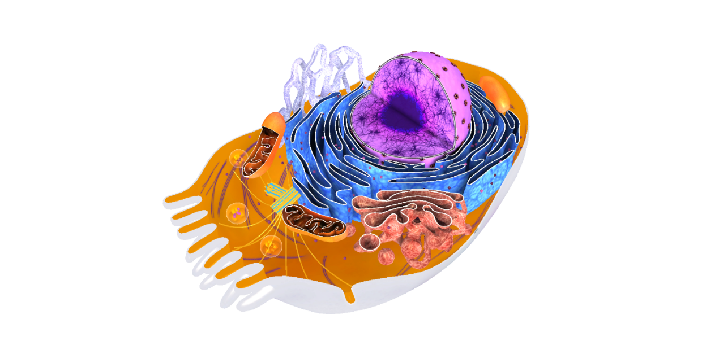

Let's also remind ourselves what the RNA model looks like and what it consists of from the chemical point of view:

And finally, have a one more look at the coronavirus model:
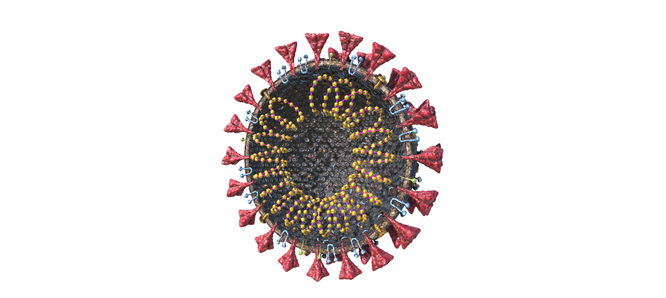

Click through the different parts of the model and focus on the “Spike Glycoprotein (S)”, as that is the part by which the virus traps cells on the inner surface of the human (as well as bat or legume) lungs, heart, kidneys or intestines and where the protein angiotensin convertase (ACE-2) enters and uses the ribosomes of the cell to replicate its RNA and multiply.

Because the exact mechanism by which the virus attacks and replicates in the cells of the human body is not yet known in early April 2020, we use information based on studies of SARS and MERS.

In general, the multiplication of viruses happens by so-called replication. It usually has 4 phases:
- Attachment – binding of the virus to the cell; This is a specific process requiring the presence of a cell surface receptor and a virus surface ligand
- Penetration – penetration of the virus into the cell
- Biosynthesis – its own replication
  - Release of nucleic acid from the capsid
  - Viral nucleic acid replication
  - Synthesis of viral proteins
- Maturation – completion of replication and release of the virus from the cell (the infected cell then either loses its function, dies or, in exceptional cases, initiates cancer)

Resource: https://en.m.wikipedia.org/wiki/Virus

Refer to the picture below to see how a life cycle of a virus looks like:

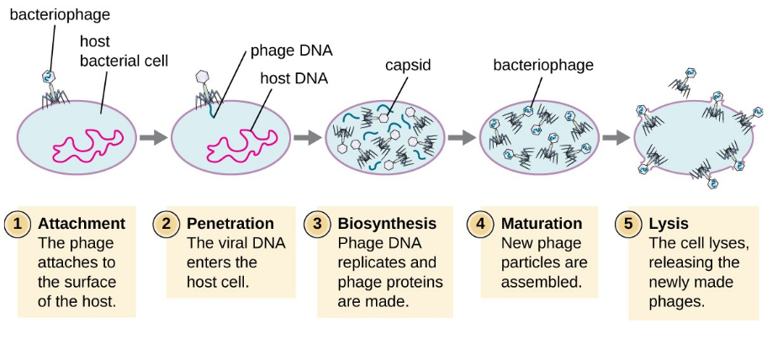
Resource: https://courses.lumenlearning.com/microbiology/chapter/the-viral-life-cycle/

For a detailed illustration of SARS-CoV-2 coronavirus mechanism of action refer to this video (2:33-4:31):

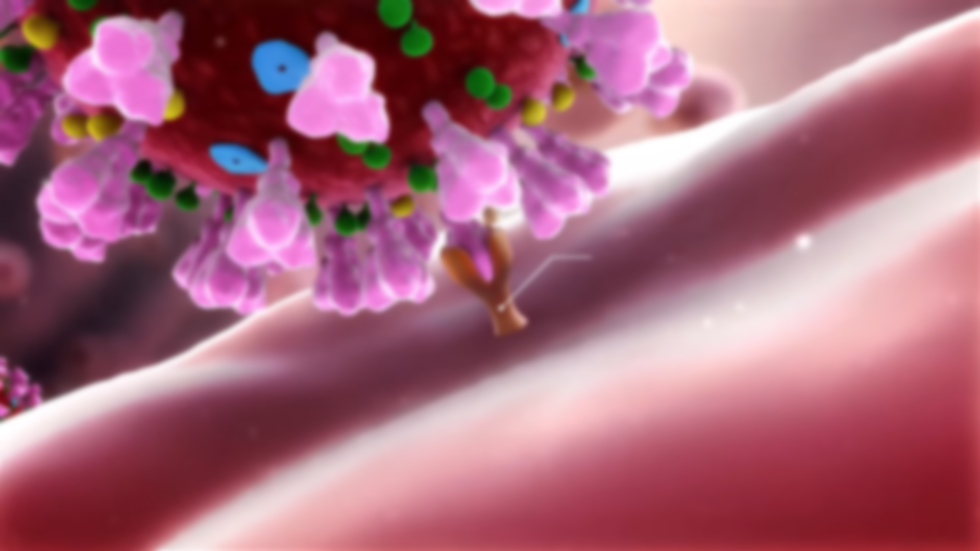

Learning activity
Today, you learned how the virus spreads and infects human cells. But what did you learn about coronavirus in general from newspapers and news? Could you recognize the so-called "fake news"? Try to find some examples of false information or distorted statistics or data on the Internet and comment on them with your own (counter) arguments or quotations from more credible sources. You can then share the created "did you know" using your social network and educate your friends and loved ones.

You can get some inspiration here:
https://www.europarl.europa.eu/news/en/headlines/society/20200326STO75917/disinformation-how-to-recognise-and-tackle-covid-19-myth

