student

The difference between COVID-19 and influenza
Life Science, Biology

In this lesson, we will focus on comparing the COVID-19 pandemic with common influenza, which is similar but has more serious complications, mainly due to its rapid and often unnoticed course. We will also find out what can be caused by the body’s own immune system and finally, we will create an infographic about the course of the disease in the human body.

- Comparison of the COVID-19 disease with common influenza
- Cytokine storm
- Learning activity

virus, coronavirus, influenza, infectivity, hospitalization, mortality

Comparison of the COVID-19 disease
with common influenza
Just like influenza, Covid-19 is of viral origin, caused by a virus whose genetic material is stored in the form of ribonucleic acid (RNA). Take a look at the influenza virion model and compare it with the coronavirus model:
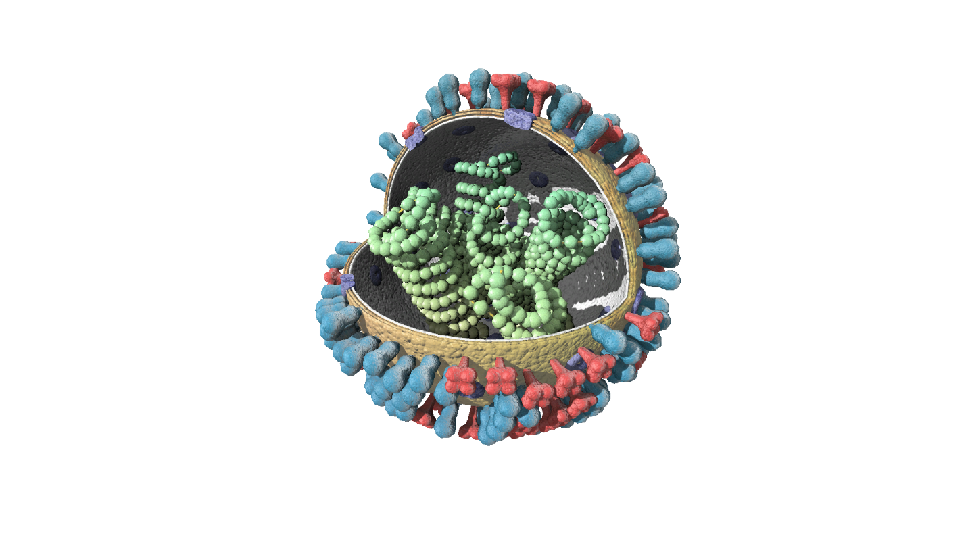

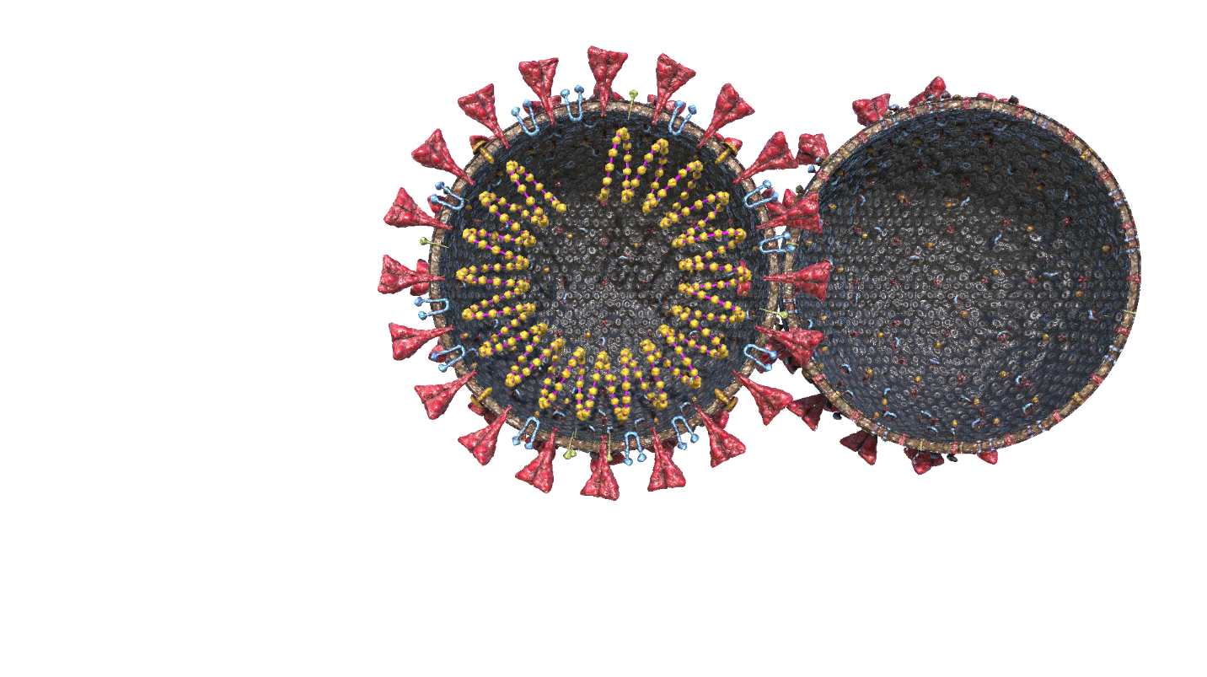

- What do both virions have in common?
- What does the "corona" in “coronavirus” mean?
- How can you protect yourself from the influenza infection?
- Do the same rules apply for protection from SARS-CoV-2?

Let’s remind ourselves of some basic information about viruses:

- Viruses are so-called obligate parasites, no virus is able to live without its host.
- The host can be essentially any organism.
- Not every virus infection causes a disease, its course is often without any observable symptoms (this partly also applies to coronavirus). However, many viruses cause serious diseases: viral diseases of the lower respiratory tract (influenza, as well as coronavirus), AIDS, virus-induced diarrhoea, but also measles are at the forefront of human mortality statistics from infectious diseases.

As already mentioned, the coronavirus mainly attacks the cells of the respiratory tract, so let's look at what the model of the lower respiratory tract looks like:
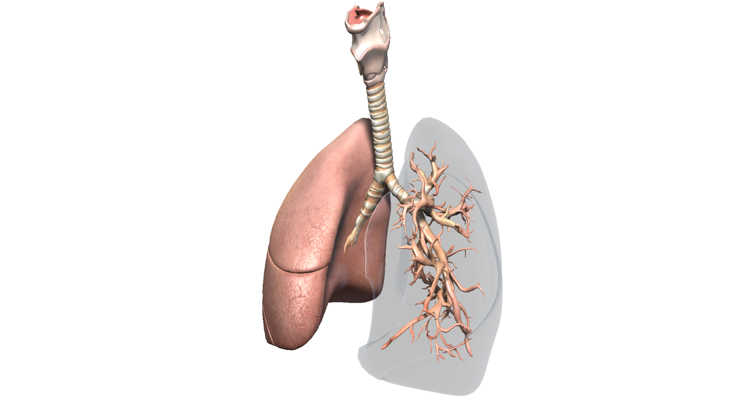

So what are the differences between Covid-19 and influenza?
Influenza has the infectivity rate (or R₀) of only about 1.5, which means that each patient infects an average of 1.5 more people. In contrast, covid-19 without social distancing has an R₀ of about 2.5.
The second measure of the virus is how often infected people have to be hospitalized. With seasonal influenza, it's about 1 percent; for coronavirus, the estimated range is from 5 to 20 percent. Higher R₀ and higher hospitalization rates can cause chaos in society. A single person with influenza can infect another 386 people in two months, and very few of them would be hospitalized. But one patient with covid-19 would infect 99,000 people in the same period, of whom about 20,000 would have to be hospitalized.
The third factor is mortality, the "mortality rate for those infected", or the percentage of people who become ill and eventually die from it. For influenza, it's about 0.1 percent. For covid-19, this is still uncertain, but even under optimal circumstances, mortality can be as much as ten times higher, about 1 percent - although in some countries, such as Italy, with an elderly population and congested hospitals, mortality was much higher.

Resources: https://www.wikiwand.com/en/Coronavirus_disease_2019
https://www.medicalnewstoday.com/articles/coronavirus-vs-flu#summary

Summary: Patients requiring intensive care (extracorporeal circulatory system or ventilator to facilitate breathing) can literally flood hospitals and overload their capacity if the disease is widespread, even though only a small percentage of the total are infected. The problem is that the infection spreads relatively quickly and is hidden for a long time (also due to asymptomatic patients) and its development is drastic in high-risk patients. To learn more about the consequences of uncontrolled infection, see the lesson on individual and state measures.

Cytokine storm
COVID-19 presents yet another risk: although the serious course of the disease is the greatest risk for the elderly, young people without a known chronic disease also die from Covid-19. A potential cause of death may be an exaggerated autoimmune reaction.

According to Jimmy Whitworth of the London School of Hygiene and Tropical Medicine (LSHTM), the severity of the disease appears to be related to the so-called cytokine storm, where a severe immune response occurs, in which the body produces immune cells and proteins that can destroy other organs. It can also happen that a weakened immune system cannot withstand a subsequent bacterial infection or can cause irreversible damage to organs.

The following animation will help you understand the process (0:30-4:55):

Learning activity
Can you find models of other organs that COVID-19 may attack in Corinth or within the Lifeliqe online platform?
Hint: we have already said that it is mainly the respiratory and digestive system.
If you find a suitable model, you can use the Share function to take a picture of it (or pictures of multiple organs) and create an infographic about the course of the disease.

