student

Individual and state precautions against COVID-19
Life Science, Biology

In the final lesson, we will review what hygiene precautions need to be taken to prevent infection and explain how to use protective equipment. In the second part, we will look at how the representatives of states, countries, and companies react to the current pandemic to prevent massive economic and social damage. Finally, we will be able to create an information poster for our loved ones.

- Individual protective precautions
- Worldwide spread and protection precautions at the national level
- Learning activity

virus, coronavirus, disinfection, facemask, respirator, prevention, mitigation

Individual protective precautions
As we have learned, the influenza virus and the SARS-CoV-2 virus (causing COVID-19) are transmitted by droplets (sneezing, coughing, sputtering), physical contact, contaminated objects or surfaces. For this reason, preventive hygiene precautions are applied:

- frequent hand washing or use of disinfectants (on hands and frequently used surfaces, i.e. handles, mobile phones, computer keyboards, etc.)
- proper "respiratory" etiquette (to sneeze not into the hand but rather into the bend of the elbow or into a tissue, which one immediately throws away)
- not touching your face with dirty hands (the virus can enter the body through the nasal mucosa or the eye)
- reduction of social contact to a minimum (staying at home, keeping a distance from others of at least 2 meters in public space, etc.), we will learn more in the next part of the lesson

So how to wash your hands properly (especially after contact with foreign (public) surfaces, another person, after coming from outside, before eating)? According to scientific studies, the most important is the length and thoroughness of washing your hands with a soap for at least 20 seconds - the soap and alcohol in the disinfectant will disrupt the lipid envelope of the virion and thus destroy it. For example, you can follow the instructions here: https://www.who.int/gpsc/clean_hands_protection/en/, or watch an illustrative video where color is used instead of soap:

Face masks, respirators, face shields
The evaluation of whether to use a cloth mask or respirator to cover your face depends on the evaluation of the risk of the environment in which the person moves and the activity he or she carries out. Using special protective equipment in the wrong places may result in a lack of the equipment. Find out where the protective equipment is used:

- FFP3 respirators, as well as eye protection, should be used primarily by healthcare professionals working in environments with a high probability of contact with infected aerosols, such as emergency admissions in hospitals or infectious disease clinics with infected patients, or by emergency medical staff or laboratory staff (COVID centers). Respirators or half masks at the FFP3 level are also recommended for use by wastewater treatment plant workers who are in the vicinity of water vapor operation technologies.
- FFP2 respirators are suitable for professions such as doctors, general practitioners, outpatient specialists, pharmacists. Furthermore, these respirators are suitable for medical staff at sampling points and dentists, who should have respirators supplemented with a shield. FFP2 respirators are also suitable for salesmen, public transport drivers, firefighters, police officers and members of the military, as long as they are in frequent direct contact with the public. Last but not least, they should be used in the food industry, in so-called “cleanrooms”.
- Disposable facemasks, cloth facemasks, or FFP1 respirators are recommended for ordinary citizens, other professions and activities, including workers in industry or the food industry.

Resource: http://emag.medicalexpo.com/which-masks-actually-protect-against-coronavirus/

And why, as an ordinary citizen, should you wear a facemask when it probably doesn't protect you from the infection anyway? The reason is simple - by wearing facemasks, we protect people around us from droplet infection coming from ourselves. However, when using a protective facemask, remember the recommendations from the following video:

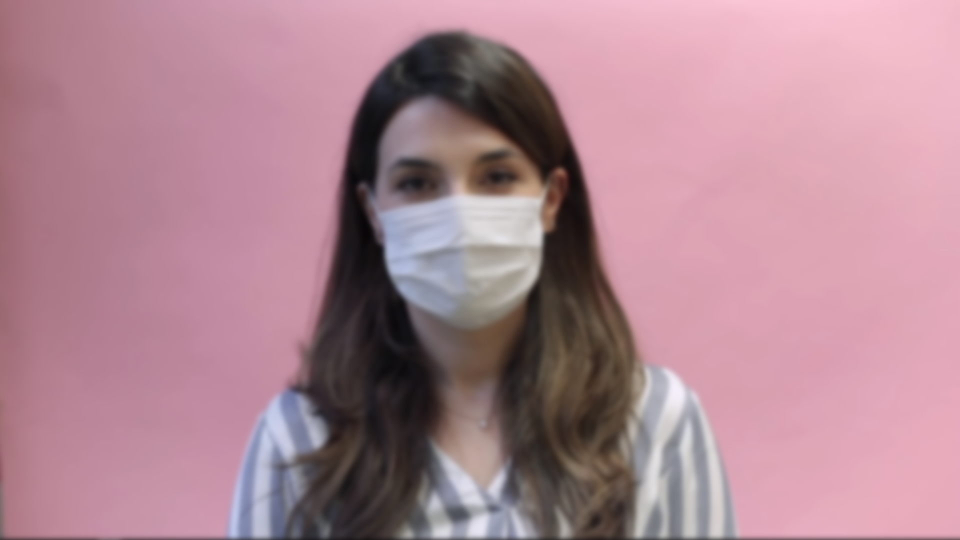

Worldwide spread and protection precautions at the national level
Let's take a closer look at how fast the virus is spreading worldwide. The World Health Organization has declared the spread of Covid-19 a pandemic on March 11, 2020, approximately two months after the (official) death of the first patient in China (January 9, 2020) and the first official tests for the diagnosis of the causative agent (SARS- CoV-2; January 12, 2020). Although China tried to stop the spread, the first cases outside its borders were registered around mid-January, and since then the number of cases worldwide has begun to grow exponentially.
Resources: https://en.wikipedia.org/wiki/2019%E2%80%9320_coronavirus_pandemic

We can clearly see the spread of the disease using an interactive scene in the Corinth app called “SARS-CoV-2 - 32 days of spread development” (unfortunately not yet available online), a video here (1:32-1:52)

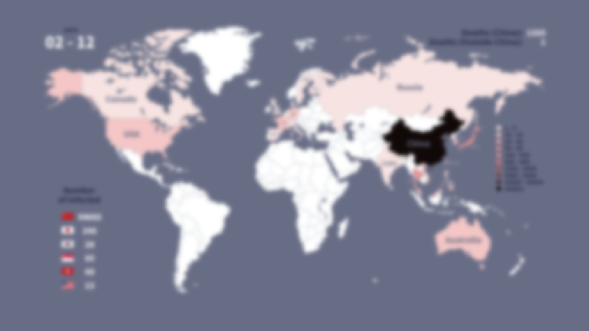

Or using this animation (0:00-0:25):

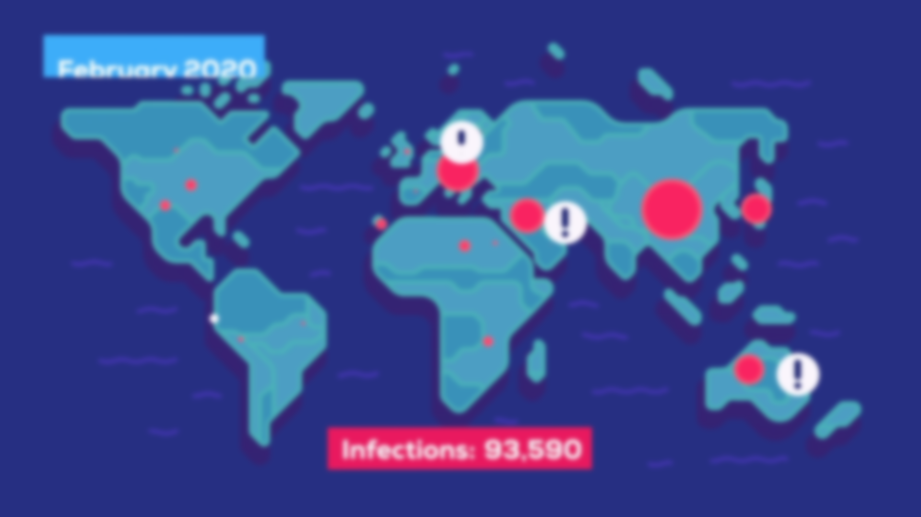
Now read the following problem and study the chart below:

Although the course of the disease is mild in most patients, approximately 20 % of cases require hospitalization, 5 % require ICU (intensive care unit) and about 1 % require very intensive treatment with specialized lung ventilators or ECMO (extra-corporeal oxygenation). .
If many people get sick at once, it will put a lot of pressure on the state health system, so states and countries should at least try to reduce the spread of the disease. The more we reduce the number of infections, the better our health system will manage, thus reducing mortality. If we prolong this over time, we will reach a point where it will be possible to inoculate the rest of the population, thus completely eliminating the risk of coronavirus. Therefore, our goal is not to get rid of coronavirus carriers, but to hold them back. An important factor is therefore the time/speed with which states intervene. Given that the number of actual cases is even much higher than the official number of identified patients, it can generally be said that the sooner the better, and every day counts.
This is illustrated by the following graph (here as an animated gif):

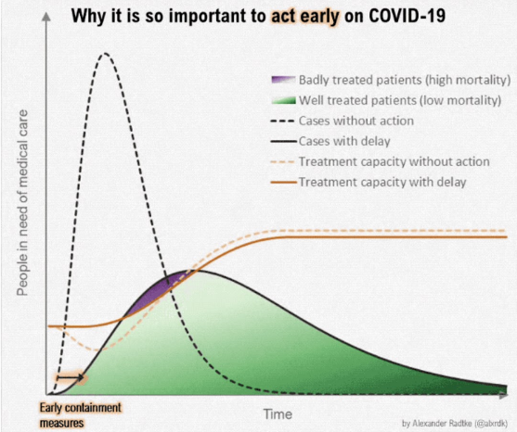
Resource: https://medium.com/@tomaspueyo/coronavirus-act-today-or....
Mitigation strategy vs. Suppression strategies
The heads of states and countries are facing difficult decisions about how to implement strict precautions and how much they will endanger their economy on the one hand and people's lives on the other. So what can they do? Read about each option and answer the questions below:

They have three options:

- Do nothing. Unrestrained coronavirus means the collapse of the health system, which in turn mean high death rates due to a lack of equipment and medical supplies for patients with coronavirus, as well as all other common acute cases (including unnecessary deaths from heart attacks and the like).
- Choose a "mitigation strategy". This means not trying to prevent the epidemic, but only to flatten the curve a little. Mitigation strategies still mean creating a massive epidemic, swallowing the health system, killing millions of people and releasing new mutations in the world.
- Choose a "suppression strategy". This means trying to apply strict precautions to bring the epidemic under control quickly. States can prevent going out for a few weeks to gain time to create a plan to educate citizens and control the virus until a vaccine is available.

More details on state strategies and precautions can be found in this article:
https://medium.com/@tomaspueyo/coronavirus-the-hammer-and-the-dance-be9337092b56

- How can individual countries try to prevent the spread of the disease?
- Why is it necessary to "flatten the curve" of the number of people infected?
- What are the disadvantages of the mitigation strategy?

Learning activity
Process the information obtained on how an individual should protect himself in the form of a graphic poster entitled "How to protect yourself from the COVID-19 infection". Create an A3 - A2 information poster using images, newspaper texts and professional sources, whether in electronic or physical form. You can draw, use model screenshots from Lifeliqe, etc. You can post the created poster in a public place.

Other important sources of information:
https://www.worldometers.info/coronavirus/

https://www.cdc.gov/coronavirus/2019-ncov/index.html

