What is SARS-CoV-2
Teacher instruction
Duration: 45 minutes
Life Science, Biology

In this lesson, we will explain what a virus is, what it consists of, and how the new coronavirus SARS-CoV-2 looks like. We will compare viruses with bacteria in terms of treatment of infections they cause and finally, we will try to think of what a completely new virus could look like.

- Introduction: What is a virus
- The origin and structure of the new coronavirus
- The difference between a virus and a bacterium or why antibiotics
do not work on COVID-19

virus, coronavirus, reproduction, infection, bacteria, antibiotics

Students will be able to:
- give examples of how individuals can protect themselves from COVID-19
- give examples of protection strategies at national level
- evaluate the possible economic and social impacts of the pandemic

Introduction: What is a virus
In the introductory part, students will find out what properties viruses share with living organisms and in which they differ.
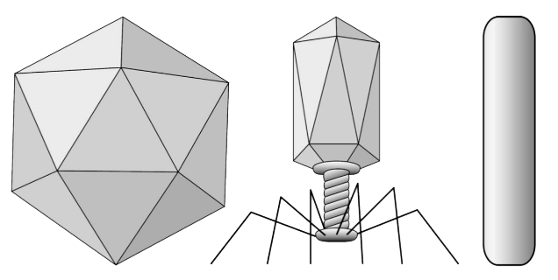

- What are viruses?
- Are they alive?
- What body parts do you think they need for their survival?

This is followed by a description of what a virion is and its structure:
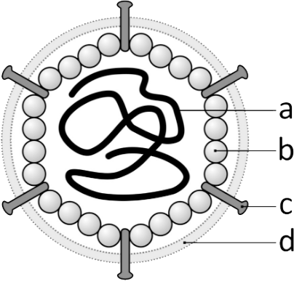

The origin and structure
of the new coronavirus
In the second part, students will work with the coronavirus 3D model. They will explore it, study the theory in the Introductory section, and observe the inner structure of the virus with additional description available.
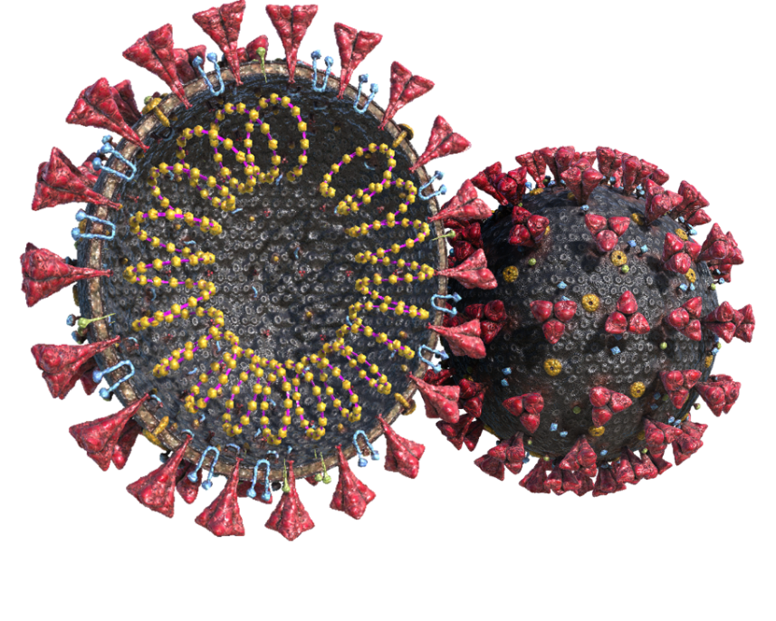

The difference between a virus
and a bacterium and why antibiotics
do not work on COVID-19

The last part is a description of bacteria and their comparison with viruses.

- Why aren’t antibiotics working on viruses?
- Do antibiotics endanger a patient's health?
- What are bacteria and how do they differ from viruses?
- Could you tell us what the disadvantages come from the overuse of antibiotics?

Learning activity

Invent and draw a completely new virus and name the important parts it must contain.
There is no need to go into great detail, but think about how such a virus can arise, how and whom it chooses as its host, and how the host can protect itself against infection.

