Spread and replication of SARS-CoV-2



Duration: 45 minutes

Teacher instruction

Life Science, Biology



In this lesson, we will focus on how viruses spread from host to host, what are the symptoms of the COVID-19 disease and how the virus behaves when it enters the host’s body – how it attacks cells and uses their system for its own replication. Finally, we will try to identify common fake news connected to the 2020 pandemic.



1. Spread of viruses
2. Connection to the human body cell and replication
3. Learning activity



virus, coronavirus, replication, infection, glycoprotein, absorption, spreading



Students will be able to:

* explain how virions spread from host to host
* describe the process of how the host cell is being attacked
* explain how virions spread (the replication process)

## Spread of viruses

In the introduction, students will revisit important general information about the transmission of virions to the host, including an illustrative [gif](https://www.youtube.com/watch?v=9qqHOKUXY5U&app=desktop) and a [video](https://m.youtube.com/watch?v=MKAHNoni0KI) about the transmission of droplet infections.

[](https://m.youtube.com/watch?v=MKAHNoni0KI)



* How does the SARS-CoV-2 spread?
* Can an infected person spread the disease before the first symptoms appear?
* How are patients tested for the infection?

## Connection to the human body cell and replication

In the second part, students will learn more about how the virus itself becomes infected. The [somatic cell](https://online.lifeliqe.com/app/scene/p_clov_zvireci_bunka?stat=sharedAccess), [RNA](https://online.lifeliqe.com/app/scene/c_hemi_rna?stat=sharedAccess), and [coronavirus](https://online.lifeliqe.com/app/scene/p_clov_cov2_online?stat=sharedAccess) models will be their visual aid.

](https://online.lifeliqe.com/student/DfsbVx)

](https://online.lifeliqe.com/student/EY6mag)

:

](https://online.lifeliqe.com/student/Wsabn3)

This is followed by a description of the life cycle of viruses, including an illustrational [video](https://youtu.be/I-Yd-_XIWJg) on SARS-CoV-2.

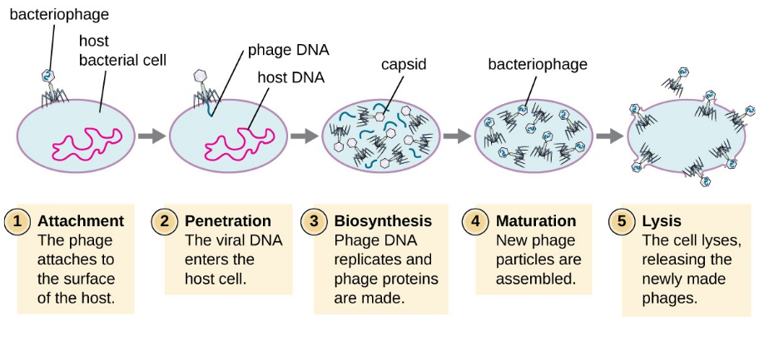

[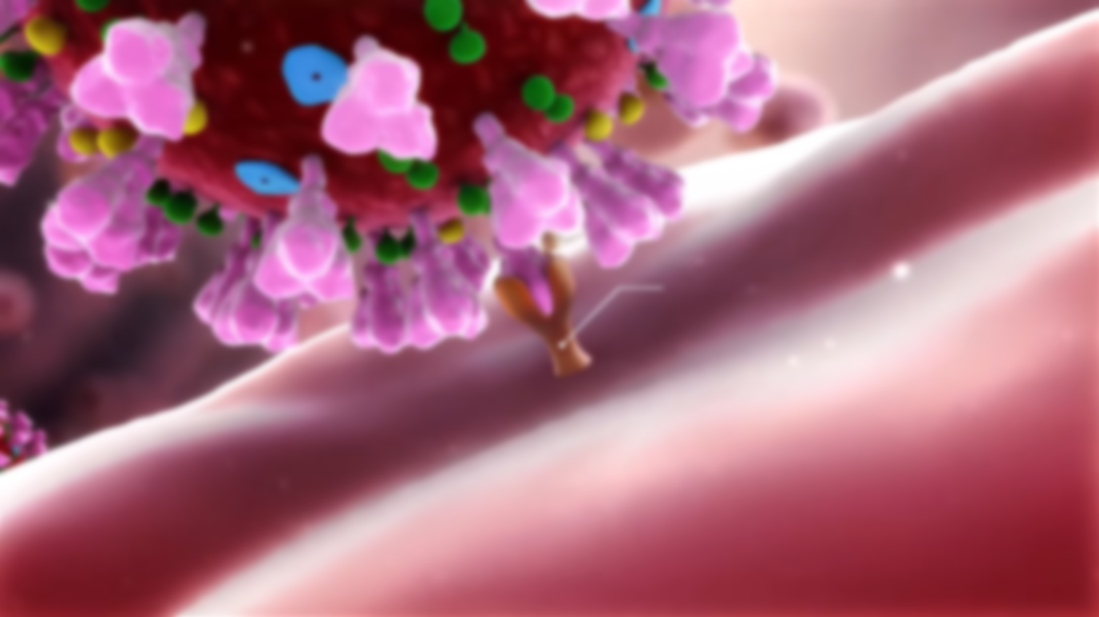](https://youtu.be/I-Yd-_XIWJg)

## Learning activity

Students will search the Internet for various reports on coronavirus spreading on the Internet, trying to identify misinformation and fake news based on official information from credible sources. Discuss the results of their search within the class.

You can get some inspiration here:

[https://www.europarl.europa.eu/news/en/headlines/society/20200326STO75917/disinformation-how-to-recognise-and-tackle-covid-19-myth](https://www.europarl.europa.eu/news/en/headlines/society/20200326STO75917/disinformation-how-to-recognise-and-tackle-covid-19-myths)