The difference between COVID-19
and influenza
Life Science, Biology
Duration: 30 minutes
Teacher instruction

In this lesson, we will focus on comparing the COVID-19 pandemic with common influenza, which is similar but has more serious complications, mainly due to its rapid and often unnoticed course. We will also find out what can be caused by the body’s own immune system and finally, we will create an infographic about the course of the disease in the human body.

- Comparison of the COVID-19 disease with common influenza
- Cytokine storm
- Learning activity

virus, coronavirus, influenza, infectivity, hospitalization, mortality

Students will be able to:
- explain the difference between influenza and COVID-19
- give examples of attacked organs
- describe the course of the COVID-19 disease
- evaluate the danger of a pandemic

Comparison of the COVID-19 disease
with common influenza
Students will compare influenza and coronavirus viruses using their 3D models.

- What do both virions have in common?
- What does the "corona" in “coronavirus” mean?
- How can you protect yourself from the influenza infection?
- Do the same rules apply for protection from SARS-CoV-2?

This is followed by a revision of basic information about viruses.

Students will then learn more about the signs and consequences of the coronavirus infection while exploring the lower portion of the respiratory tract 3D model.

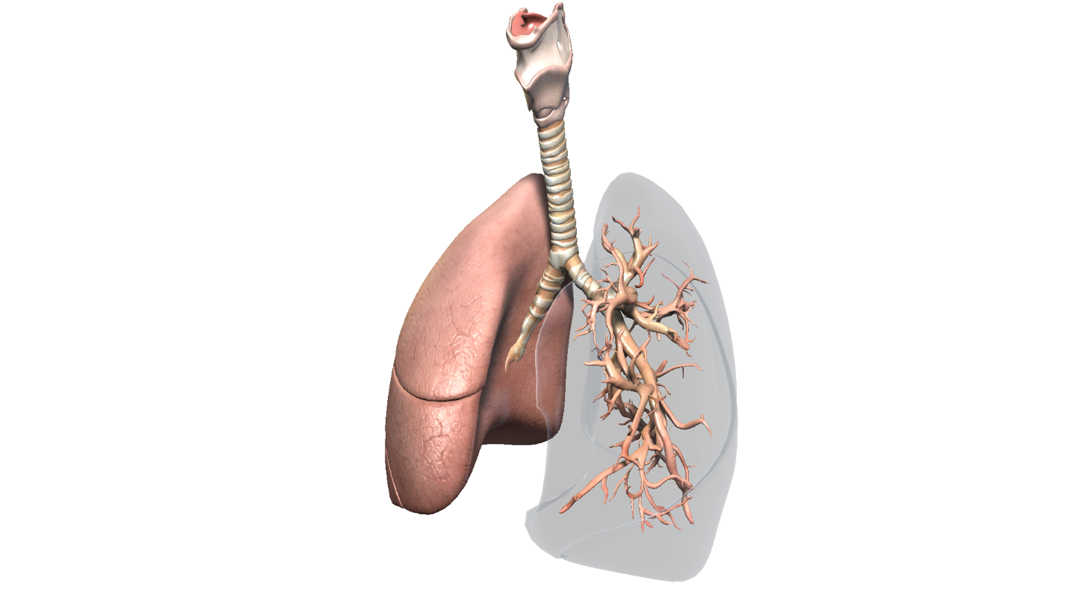

Cytokine storm
Then, with the help of the description and video, they will learn more about the possible exaggerated autoimmune response to the infection, the so-called cytokine storm.

Learning aktivity
On the Lifeliqe online platform, students will search for models of other organs that can be attacked by COVID-19. Then they will take pictures of the models using the Share feature to create an infographic about the disease and present it.

