Individual and state precautions against COVID-19
Duration: 50-60 minutes
Teacher instruction
Life Science, Biology

In the final lesson, we will review what hygiene precautions need to be taken to prevent infection and explain how to use protective equipment. In the second part, we will look at how the representatives of states, countries, and companies react to the 2020 pandemic to prevent massive economic and social damage. Finally, we will be able to create an information poster for our loved ones.

- Individual protective precautions
- Worldwide spread and protection precautions at the national level
- Learning activity

virus, coronavirus, disinfection, facemask, respirator, prevention, mitigation

Students will be able:
- give examples of how individuals can protect themselves from COVID-19
- give examples of protection strategies at national level
- evaluate the possible economic and social impacts of the pandemic

Individual protective precautions
Students will learn about how the virus can enter the human body and also about good hygiene techniques, a video included.

The next up is information on protective equipment, such as masks and respirators, again including a video.

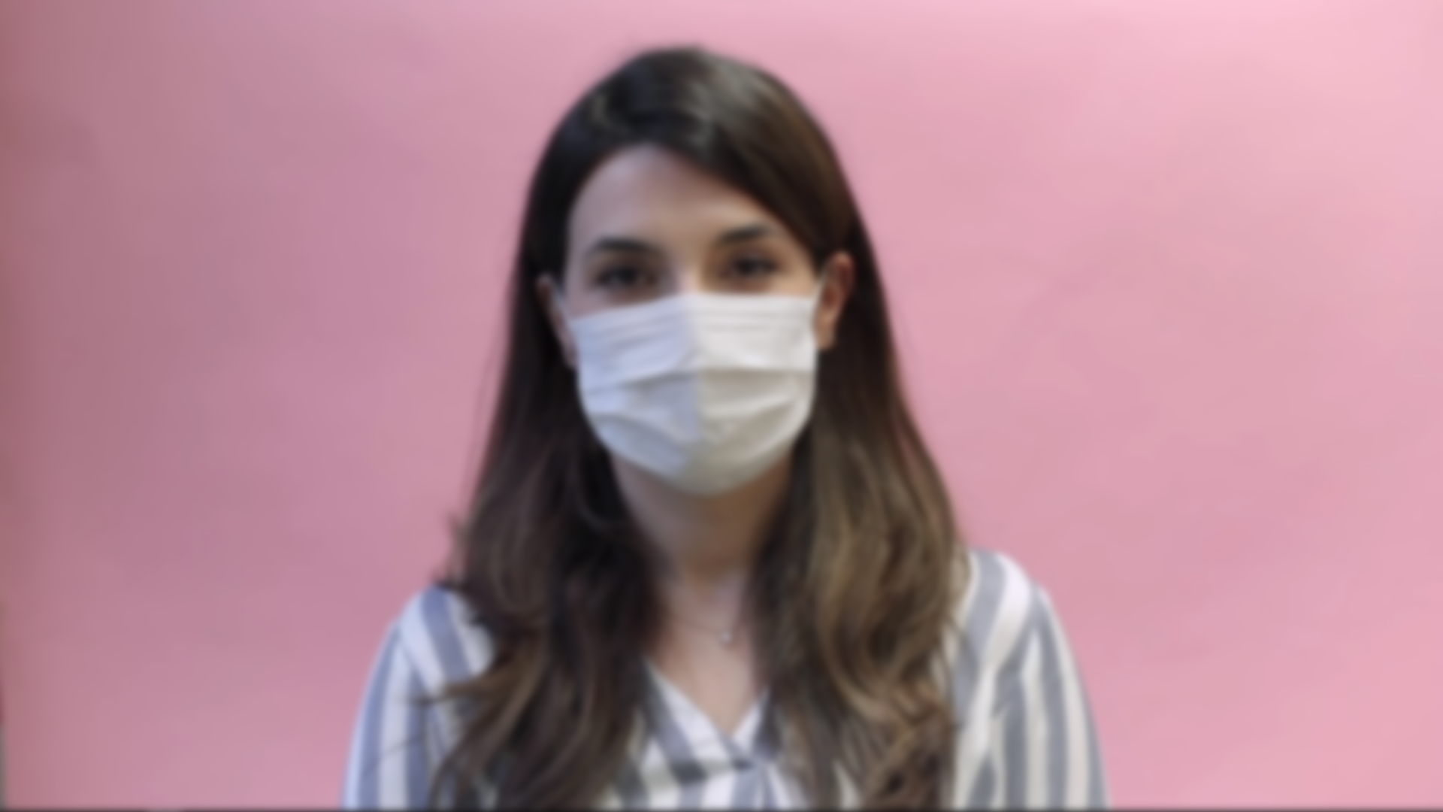

Worldwide spread and protection precautions at the national level
The second part of the lesson will introduce students to the spread of coronavirus infection around the world using an interactive scene in the Corinth application called “SARS-CoV-2 - 32 Day Spread Development” (unfortunately not yet available online). A video of the scene is available (1:32-1:52):

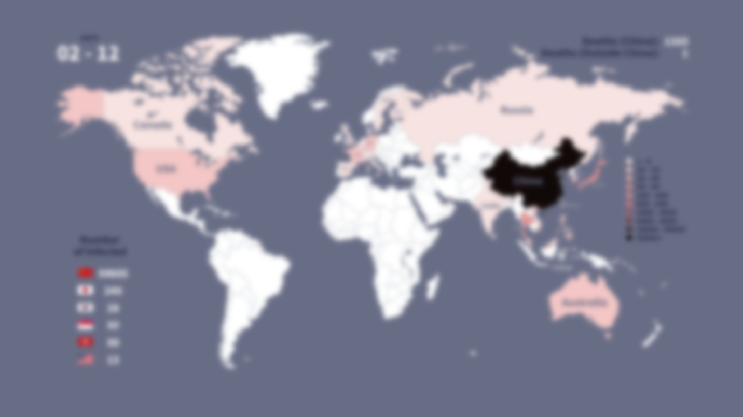

as well as an animation (0:00-0:25):

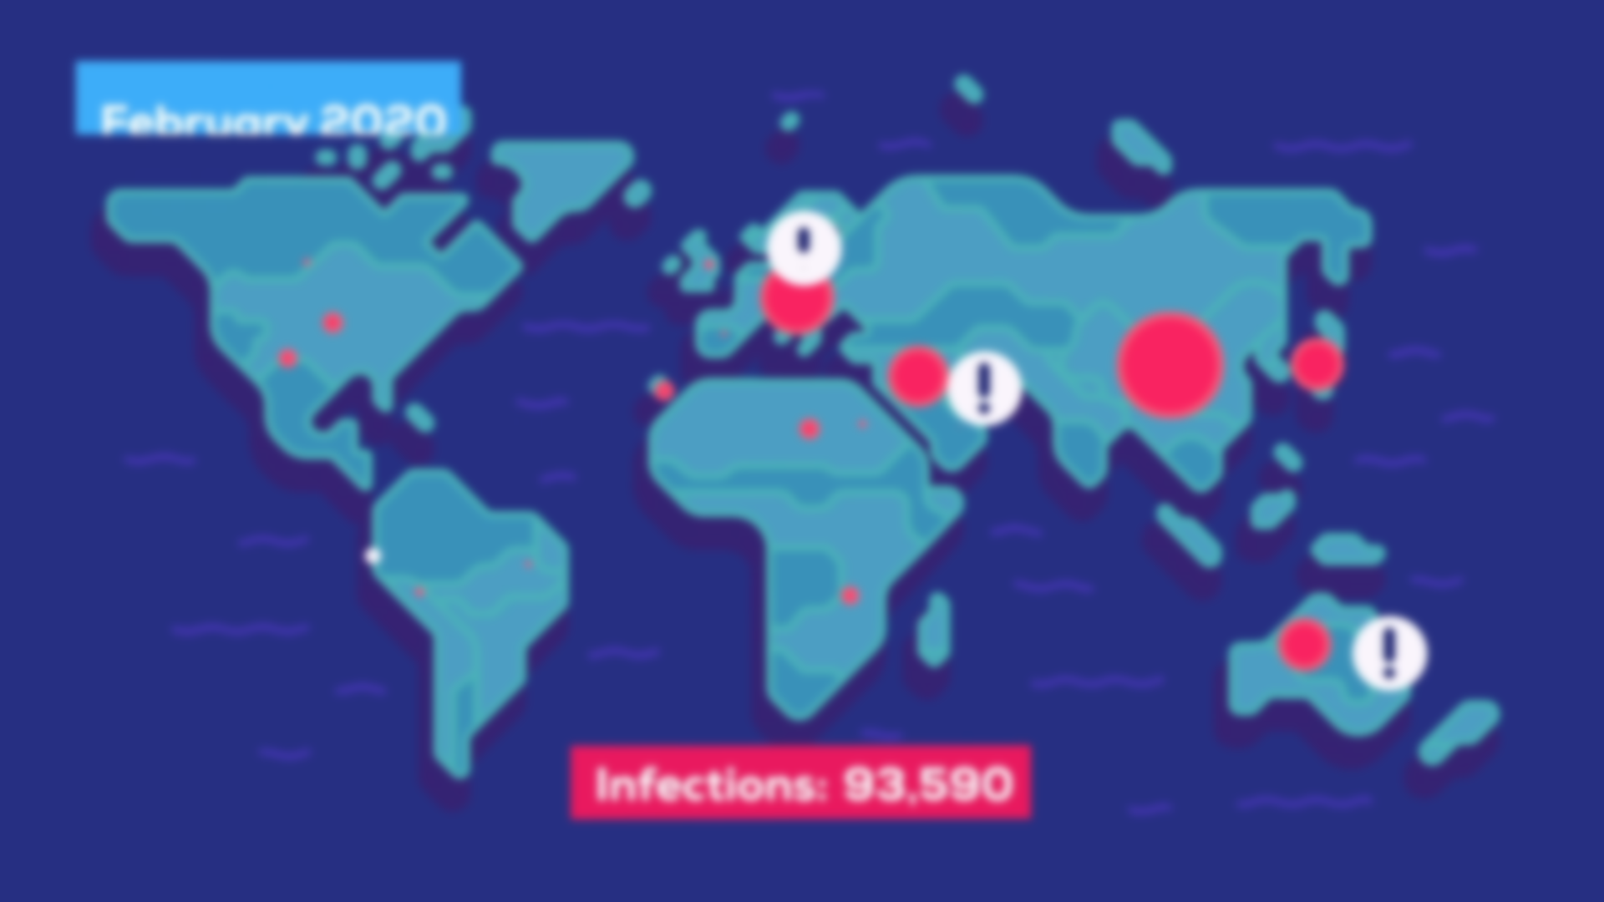
This is followed by an animated gif using a graph to illustrate the course of the infection depending on the speed and effectiveness of the precautions taken, and a description of the strategies for fighting the disease. Students will focus on the difference between the mitigation strategy vs. impact suppression.

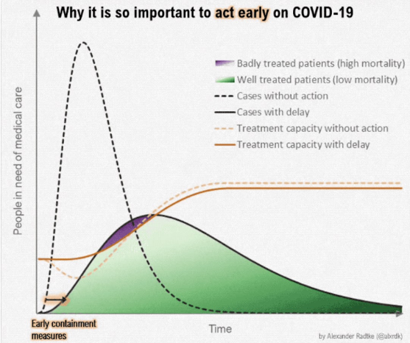

- How can individual countries try to prevent the spread of the disease?
- Why is it necessary to "flatten the curve" of the number of people infected?
- What are the disadvantages of the mitigation strategy?

Learning activity
Students can create a graphic poster on the topic of "How to protect yourself from the COVID-19 infection". They can present the created poster to others and then hang the poster on a notice-board.

